Chapter 11, Problem 61.

Given the circuit in Fig. 11.80, find I_{o} and the overall complex power supplied.

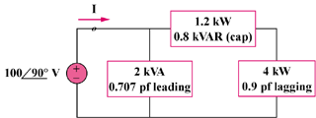

Figure 11.80
For Prob. 11.61.

